2021 Usher Serving Instructions

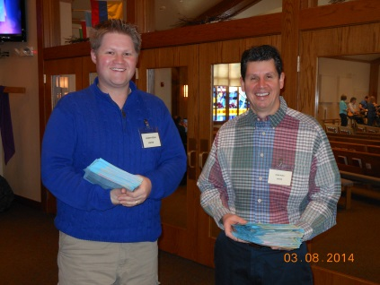
The Usher is an important Worship Service Volunteer
  - 2nd tier greeters
    - Representative of SOTH
    - Welcome all who attend – be a friendly presence and smile and say “Good morning”
    - If you know the person, greet them by name
    - Treat strangers as friends
    - Help to identify visitors and guests
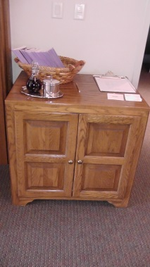
  - Answer questions – location of nursery, restrooms, etc.

The usher cabinet is located outside the Sanctuary across from the Welcome Center
  - Located in Narthex across from Welcome Center
  - Name tags located here
  - Count Sheets
  - Offering/Collection Plates
  - Wooden Plate
  - Resource binder with Usher Responsibilities / Holiday Information / Updates
  - Incident Reports (located in a manila folder in the cabinet)

Before Worship Services

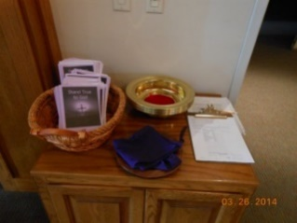
- Arrive at least 20 minutes before the service is to begin. If winter weather creates snow and ice, Ushers should keep the sidewalks clear and safe during Sunday worship. Shovels and ice are located in entryway storage closet.
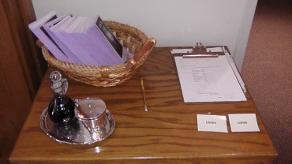

- Put on your nametag.

- Prior to 8:30 service, Baptismal font cover is removed and placed in storage closet near Welcome Center. Turn on switch, found inside Baptismal font cabinet, left side.
- Open center Sanctuary doors before 8:30 service and after choir practice.
- Turn on the light in the mother’s lounge. The mother’s lounge is the first room upon entering the women’s restroom.
- Check the order of the worship service in the bulletin copy located on the Usher cabinet, noting when communion occurs.
- Light the large “Prayer candle” on table in the back corner of the Sanctuary.
- If Sanctuary is full, help people find seats. Ask people to move together to accommodate more people.
Note: On holidays or “multiple” baptismal Sundays, additional chairs may be needed in the back of the Sanctuary and added to into the Narthex/Lobby.

IMPORTANT PRE-SERVICE DUTIES for Services with Large Attendance
    - 3-5 minutes before service starts
        - Usher walks up and down the aisles in Sanctuary to view open spots and ask people to move to center of pews
        - Usher will then signal to an Usher in Narthex to bring guests to available seats.
        - The Usher directs people to open spots, including chairs positioned at side windows and in the back of the Sanctuary near the sound board.
        - Pastor or member of Praise Band may announce for people to move together right before service.
- NOTE: If there is no Acolyte or Crucifer, the ushers may need to light candles on the altar before worship. (Note: there are no Acolytes/Crucifers during the summer months).
- Please kindly ask all worshippers to enjoy their beverages prior to entering the Sanctuary. Bottled water is okay. Young children may still have their “sippy cups” and cheerios/snacks.

During Worship Services

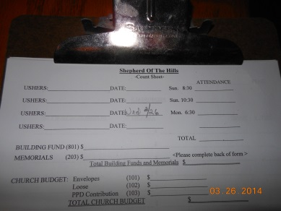
Conversations in the Narthex can be heard in the Sanctuary. Please ask anyone talking in the Narthex to move into another room or down the fellowship hall. Please remember that your conversations can also be heard!

- Count all in attendance (including those helping in the service and in the nursery.) It is best to do this during announcements before children go to Children's Church (when in session). Remember to write down the attendance numbers on the count sheet located on the Usher cabinet. And please include your names on the count sheet, too.
- Doors
- Sanctuary doors are opened before 8:30 service, after the choir practice and closed before 10:30 service at 10:30 before Praise band rehearsal.
  - Exception at 8:30 Service: Close Sanctuary doors before service, typically the third Sunday of the month when the Gospel band is rehearsing.
- Sanctuary doors are closed before reading of the lesson
  - Ushers should remain in Narthex during entire service to follow Safety protocol and to monitor people, and entrance and office doors
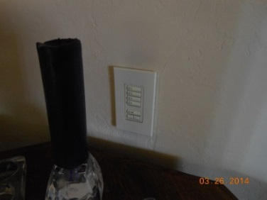
    - When possible, open Sanctuary doors for people entering and exiting mid-service to prevent noise from the doors.
    - Keep Sanctuary doors closed until the closing hymn, to reduce noise from the Narthex. Encourage those arriving, waiting in the Narthex for 10:30 worship, or in the Narthex during 10:30 worship to please lower the level of their voices. The doors convey sound from the Narthex into the church, and any time the doors are open, the noise of conversation is heard by those still in worship.
    - Walk to the Nursery again after Communion to ensure that everything is running smoothly.
    - Entrance Doors Check on strangers entering church (leaving suspicious packages, entering coat area, going into office, etc.), guide latecomers to a seat, and check nursery to see if there is a problem
    - Are things under control in Nursery? Do any parents need to be paged? Contact Amy Cichon?
  - Occasionally a visitor may enter and ask for a handout/money.
    - Ask them to have a seat to wait to talk with the Pastor or come back another day.
  - If time permits, one Usher may opt to take a walk outside in the parking lot to scan for suspicious cars
    - There have been instances of items stolen thieves stealing from unopened cars during church worship services (this has not happened at SOTH).
    - Office Door - make certain the office door near main church entrance is locked and secured. The entrance to the office through the Family Bathroom hallway should remain open.
    - North Door (Near Kitchen): Usher verifies door is locked during church service. This door is used for ingress/egress by Sunday School participants. This door is locked at all times except between 9:15 A.M. to 9:40 A.M., and from 10:20 A.M. to 10:40 A.M. to allow access by parents and children when Sunday School is in session (Sept.-May). These doors should be monitored by staff when unlocked.

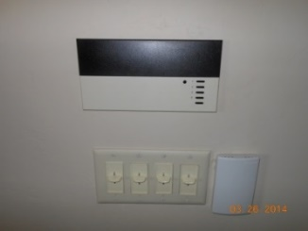
- Nursery Area - Are things under control? Do any parents need to be paged? Contact the Children’s Ministry Director. Inform Children’s Church Leader when sermon is finished to return children to church.
- On occasion throughout the year, the children’s choir rehearses from 10:30-10:50 in the Music Room. At 10:50, some children will go to Children’s church and some will find their parents in the Sanctuary. If needed, help to guide them quietly into the Sanctuary at a point in the service that is the least distracting.

- Control Lights/Sound/Stained Glass Window Shades:
- Control panel by the Prayer candles in the back of the Sanctuary dims / turns off only the Sanctuary lights.
- Control panel behind the sound board incrementally dims both the lights in the Sanctuary and the Narthex simultaneously. The buttons from top to bottom are ordered from bright to dim to completely off.
- Work with the AV/Sound Board volunteers to determine who will operate this control for services when it is needed.
- Duties involving these controls are performed mostly at holiday services but may occasionally be needed for video clips or special announcements.
- Alert sound board volunteers to turn the volume up or down in the Narthex.
- When needed, locate the remote control at the AV/Sound Board to lower the stained-glass window shades on the left and right sides of the Sanctuary. Aim the remote at the receiver eyes located above the glass window frames.

- Collect offering: The Offering plate is located on a stool in the Narthex, near the entry to the Sanctuary for people to add to before or after worship:
- Because because the offering plate is left unattended in the lobby while the 2 Ushers are guiding folks up to communion during that time, we look at how to ensure the envelopes and loose cash placed there prior to the end of worship remain uncompromised.
- Prior to Communion, take all offerings in the plate and place them in the green bag located on the Usher stand
- Place the bag inside the cabinet; the plate remains on the stool.
- If additional offerings are placed in the plate after worship, add those to the green bag and take the bag into the sacristy to insert in the safe.
- Direct communicants according to the directions for 8:30 and 10:30 (See ‘Communion Pattern’).

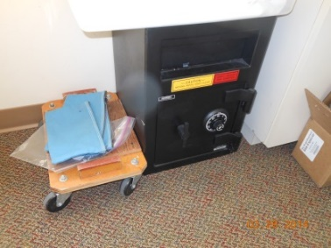
After Both Worship Services

- Sort items from offering bag and place offering envelopes in zipped bag in the Sacristy. The bags are located next to the safe in the Sacristy. Place the bags in the safe. Make sure that the money drops! Never do without at least 2 ushers present.
- Separate the Connection cards from the money and place them in the labeled box on the table across from the safe in the Sacristy.
- Items other than offering envelopes (pledge cards, surveys, etc.) should be placed in the Connection Card box if no other basket or receptacle is announced and supplied for their return.
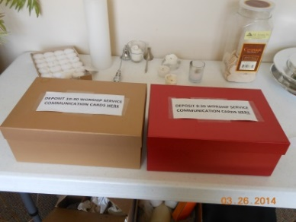
- Extinguish any candles left burning (in the summer without an acolyte, the altar candles need to be extinguished after each worship service).
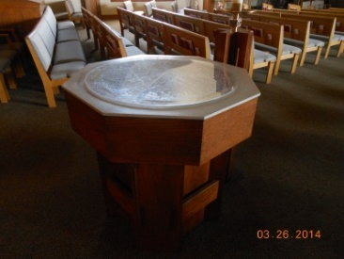
- Following the 10:30 service cover the baptismal font and turn off switch.
- Straighten up pews and remove any bulletins or other items left behind.
- Turn off the light in the mother’s lounge. The mother’s lounge is the first room upon entering the women’s restroom.
- Return name badge to Usher cabinet.

Special Note:
If the holding tank alarm goes off during Sunday worship, go to the mechanical room to silence the alarm. The mechanical room is the door located immediately to the right of the Nursery and to the left of the member picture boards. The alarm is located on the right, high on the wall over the water heater. There are instructions on the wall on how to silence the alarm and a form to fill out and return on Becky’s desk or in the church office door file if the office is locked. The forms are in a plastic sleeve near the alarm. If needed, find an available staff person to assist.

Revdr6/2021

Communion Pattern
8:30 service and 10:30 service

GENERAL COMMUNION PROCESS of Directing Communicants
  - Begin with Center sections
  - Communicants exit their pews from the aisle to the right and return via the opposite/left aisle.
  - Side sections: Communicants exit their pews also on the right and return on the opposite aisle.
  - Alert Communion Assistants of folks who may need communion delivered to their pew.
  - Remember to commune the Acolyte and Crucifer when they are serving (go to them and show them to the line) and the Choir and Band members.
  - Communion Assistants will receive communion before serving the congregation.
  - Ushers commune after all have communed.

2 Station Communion Pattern:
  - The Worship Assistant and Communion Assistants should follow Usher instruction, as needed.

- One usher handles the right pew sections, dismissing the right center section and then going to the far right (west) section. The communion assistants should start with the right middle section, then move to the west section.
  - One usher handles the left pew sections, dismissing the left center, then going to the far left (East). The communion assistants should start with the left middle section, then move to the east section.

    - The Praise Band/Choir are aware to self-direct, but Ushers should be mindful to watch and guide them, if needed.

- Remember to commune the Acolyte and Crucifer (they serve only during the school year); guide them to the communion line.
Revdr 6/2021
In Case of Emergency

Dial 911

Shepherd of the Hills Lutheran Church
1350 Hwy 175 Hubertus, WI 53033; 262-628-2633

Telephone Locations
#1 Main Office
#2 Conference Room
#3 Bookkeeper's Desk
#4 Asst. for Volunteer Ministries’ Office
#5 Pastor’s Office
#6 Kitchen
#7 Fellowship Hall (Note: Phone is “911 and answer only” - no personal calls)

Fire Alarm & Extinguisher Locations

Note: The whole building is equipped with a sprinkler system
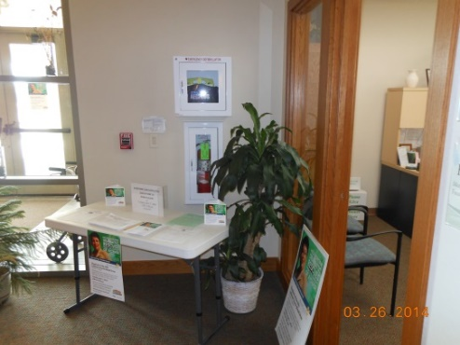
#1 Located in wall at main Front Entrance
Includes Fire Alarm and AED Defibrillation Unit
#2 Located near SE exit door in Sanctuary
Includes Fire Alarm
#3 Located outside Nursery Door
Phone activated for 911 Emergency calls only
#4 Located on east wall of Kitchen
First Aid Kit Located Above
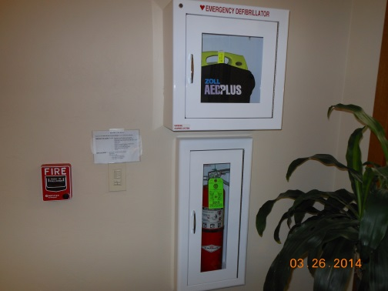
#5 Located in wall on west side Sunday School Entrance

Fire Alarm Located next to North Storage Room Door (off Fellowship Hall)
EXITS
#1 South East Sanctuary Wall
#2 Front Entrance
#3 Fellowship Hall (2 Exits): West Hallway & North Storage Room

Emergency Escape Procedures and Routes Guide
- Located on Usher Cabinet and Posted in Select Church Areas

Lock Down Floor Plan
- Located on Usher Cabinet
Incident Reports - Located in a file folder in the Usher Cabinet. After emergency incident, complete and file in the church office (see attached sample report).
Revdr 6/2021
Shepherd of the Hills Incident Report Form

Date/Time of Incident: ________/________ Reported By: _________________________
Nature of Incident: ______________________________________________________________
______________________________________________________________________________
______________________________________________________________________________
______________________________________________________________________________
People Involved: ________________________________________________________________
______________________________________________________________________________
Injuries or Medical Conditions: ____________________________________________________
_____________________________________________________________________________
_____________________________________________________________________________
Actions Taken: _________________________________________________________________
_____________________________________________________________________________
_____________________________________________________________________________
Authorities Notified (Circle all appropriate):
None 911 Sheriff Fire Ambulance

Other (Diagram, if helpful):

Signature:

